**TANKALA PARVATEESWARA RAO-PROFILE**

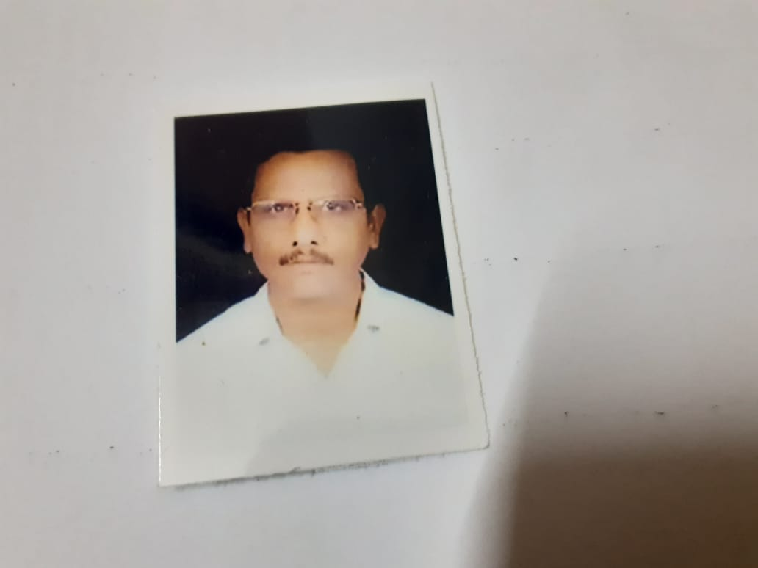

**NAME** : **TANKALA PARVATEESWARA RAO**

**Designation**   **:** Lecturer in Commerce

Govt. Degree College

PALAKONDA

Andhra Pradesh, India

E-Mail: **tankalaparvateeswararao**@gmail.com

Mob: 9398692091

**Date of Birth :** 24/03/1959

**Qualification :** M.COM

**Date of Joining**  : 02/12/2020

**Experience** : 33 years

**Address (Res) :** D.NO 7-2-8,NAKKALAPETA ,VADAMA,

PALAKONDA

PARVATHIPURAM MANYAM-532440

|  |  |  |  |  |
| --- | --- | --- | --- | --- |
| **Qualification** | **University/Board** | **Year of Passing** | **% of marks** | **Class Secured** |
| **M.COM** | Andhra university | 1982 | 65 | **1 class** |
| **B.COM** | Andhra university | 1980 | 55 | **II class** |

**Specialization: TAXATION**

**TRAINING PROGRAMMES**

|  |  |  |  |
| --- | --- | --- | --- |
| **DATE** | **NAME OF THE TRAINING** | **ORGANISED** | **TOPIC** |
| 06/02/2023TO 08/02/2023 | TOT (3 days) | APCCE | INTERNSHIP AND LMS |
| 12/06/2023 TO 17/06/2023 | TOT (3 days) | APCCE | EMI |